COLUMN  Designed for standing workstations.  Features & benefits:  - Adjustable height.  - Functional.  - With table clamp.  - Extension to 20 pockets maximum by combining 2 wall units  - Compatible sizes: A4 tarifold (ref : 41410X) ou A5 tarifold (ref: 41510X)  Key selling point:  - Vertically adjustable from 480 to maximum 700 mm. Adjustable top angle.  Places for use:  - Factories, offices, laboratories, etc.  Technical characteristics:  - Light grey column vertically adjustable.  - 1 table clamp.  - 1 telecoping column can hold 1 or 2 tarifold technic (or tarifold office) wall units.  - Delivered without any wall unit.  - Also available with flat base (Infopole, ref. 560200) to slide under a heavy object (like a cash register) or mount with screws. | 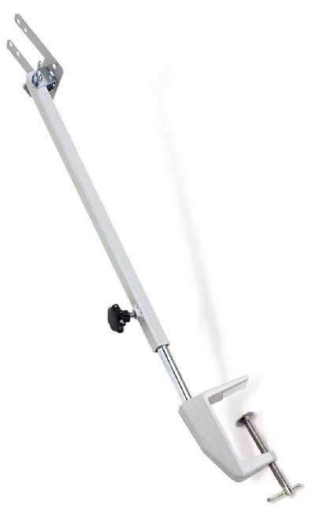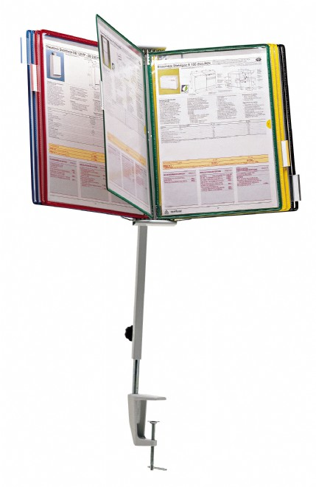

Article | Description | Size of product | Nbr of pcs per sales unit | MOQ
560100 | Grey | A5, A4, US | 1 | 1

Article | Sales unit - Weight/EAN Code | Display Box - Qty./Weight/EAN Code | Export Box - Qty./Weight/EAN Code
560100 | 756 g / EAN 3377995601008 | 20 / 16200 g / EAN 337799601008 | / g / EAN

Custom Code: 392 61 000 000 OD

