DESK UNIT MOUNTED EMPTY WITH STOPS  COMBINE THE ELEMENTS YOURSELF AND CREATE YOUR OWN DISPLAY HOLDER.  Product benefits:  - A simple, flexible system for building the holder pefectly adapted to your requirements.  Key selling point:  - Choose the pockets suitable for you (colour, format) to form a complete kit.  Places for use:  - Sturdy holders, perfect for production workshops, production lines, assembly bays, etc.  Technical characteristics:  - Light grey desk unit with 4 side stops to hold pockets.  - Without pockets.  - Extensions: from 10 to 60 pockets.  - Weight: 1,392 Kg (10 pockets) to 3,772 (60 pockets). | 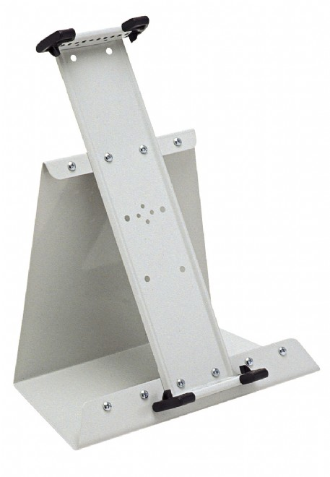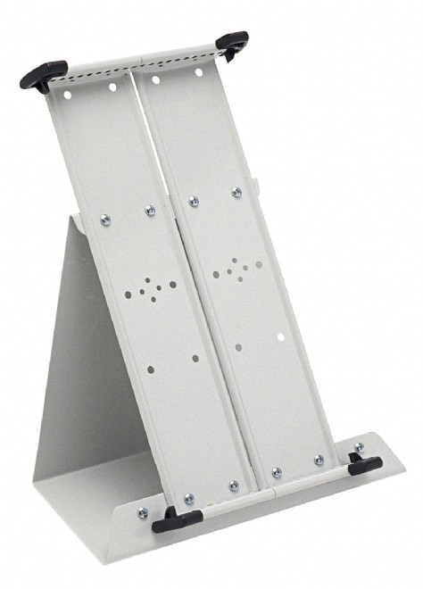

Article | Description | Size of product | Nbr of pcs per sales unit | MOQ
224100 | Grey | A4 | 10 | 1

Article | Sales unit - Weight/EAN Code | Display Box - Qty./Weight/EAN Code | Export Box - Qty./Weight/EAN Code
224100 | 1392 g / EAN 3377992211002 | N/A / N/A g / EAN N/A | 4 / 3000 g / EAN 3377990016357

Custom Code: 392 61 000 000 OD

