PIVOTING POCKETS - A4 - PP  The unbreakable Tarifold pocket in PP! This pivoting document display pocket offers flexibility, sturdiness and efficiency through its unparalleled level of quality.  Product description:  - A4 pivoting pocket for document display systems.  - Exclusive Tarifold steel wire frame technology.  - Anti-glare material.  - Portrait.  - Top loading.  - Coloured frame.  - Includes clip-on 50 mm index tabs with inserts (neutral/colour)  Unique selling points:  - Solidity of steel wire and metal pivots.  - The coloured frame both enhances the information and makes it identifiable.  - Metal frame brings flexibility and sturdiness.  - Optimum transparency for maximum readability of document.  Usage:  - Adapted to all wall and desk document display units (except the Design range).  - For use in factories, warehouses, production workshops, etc.  Technical characteristics:  - 110µ polypropylene.  - Metal pivots.  - Dimensions: 230 x 343 mm.  - Pockets returned to Tarifold are recycled: tarifold.com/pocket-recycling.  - 10 year guarantee.  - Made in France.  Packaging:  - 100% recycled Kraft cardboard box. | 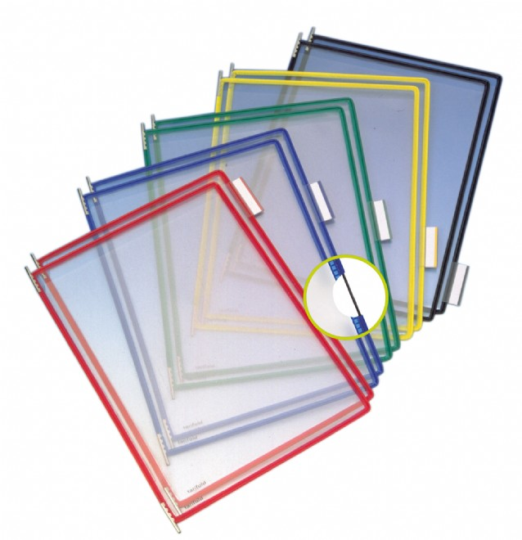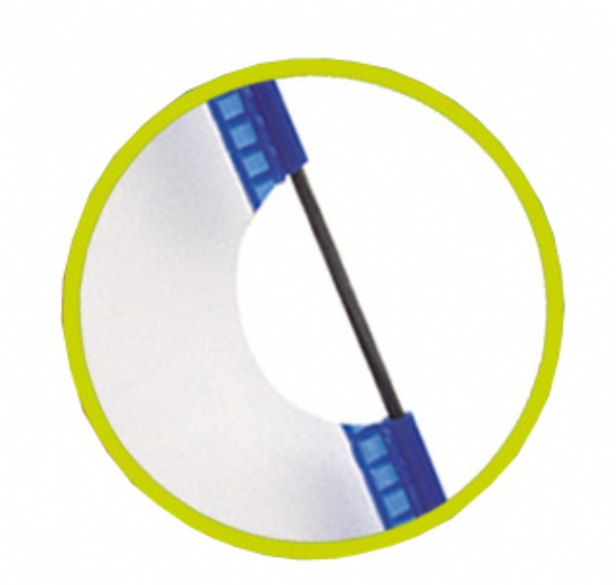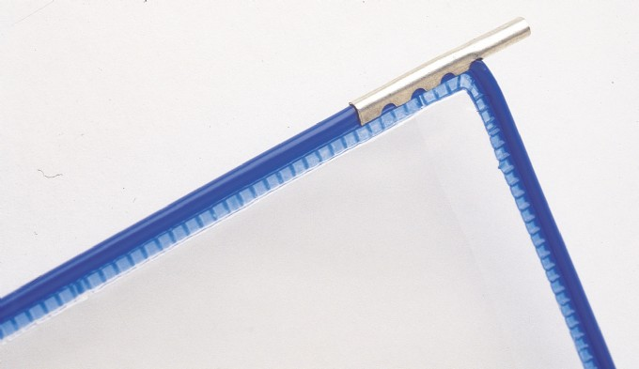

Article | Description | Size of product | Nbr of pcs per sales unit | MOQ
114031 | Bulk - Blue | A4 | 10 | 25
114032 | Bulk - White | A4 | 10 | 25

Article | Sales unit - Weight/EAN Code | Display Box - Qty./Weight/EAN Code | Export Box - Qty./Weight/EAN Code
114031 | 364 g / EAN 3377991140310 | N/A / N/A g / EAN N/A | 25 / 10100 g / EAN 3377990013530
114032 | 364 g / EAN 3377991140327 | N/A / N/A g / EAN N/A | 25 / 10100 g / EAN 3377990013585

Custom Code: 392 61 000 000 OD

